THEORY QUESTIONS

PART I

MAP SKILLS AND THE ENVIRONMENT
1.
Use the rainfall graph below to answer the questions that follow:
The graph below shows the rainfall distribution of Station A
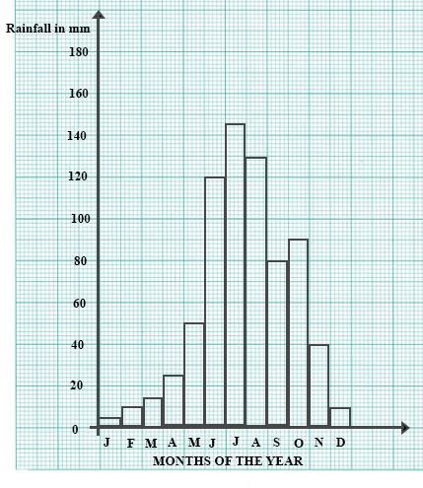
a)

Calculate the average rainfall for the first half of the year.
b)

Find the total rainfall from July to the end of the year.
c)

Which two months of the year have equal amounts of rainfall?
d)

Describe the pattern of the rainfall distribution.

2.
a)

Draw a sketch map of Ghana
b)

On your sketch map, show and name
i)

the Savanna grassland vegetation zone;
ii)

Tamale and Bawku
c)

i)

Name any two cash crops produced in the Savanna grassland.
ii)

State two ways in which one of the cash crops you named is of economic importance.

PART II

NATIONAL COMMUNITY
3.
a)

Mention four offences against the individual and four against the state.
b)

State four reasons why a country makes laws for its citizens

4.
a)

What four factors led to the growth of the Old Ghana Empire?
b)

State four factors that caused the fall of the Old Ghana Empire

PART III

WEST AFRICA, AFRICA AND THE WORLD
5.
a)

State any four aims of the Organization of African Unity (OAU)
b)

Explain any four problems facing the Organization of African Unity (OAU)

6.
a)

Describe four functions of the Food and Agricultural Organization (FAO)
b)

Name two countries which have insufficient food to feed their people.
c)

Give two reasons why poor countries should not always receive free food aid.

